**Nama : Ayu Sri Handayani**

**NPM : 4513210009**

**Laporan Praktikum 1 Pemrograman 4**

**Langkah-langkah Membuat Java Web Servlet**

Langkah pertama adalah pilih **File 🡪 New Project** lalu pilih **Maven 🡪 Web Aplication** lalu klik **Next**

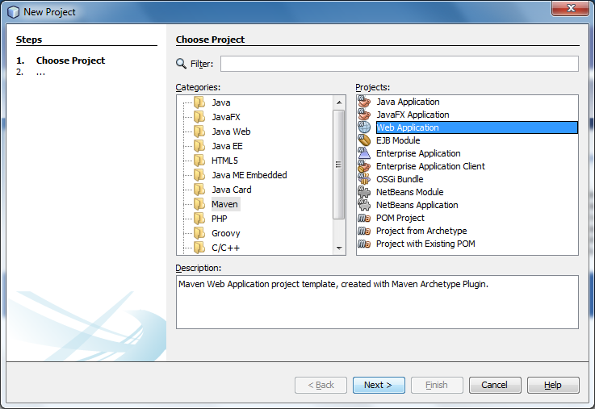

Langkah kedua adalah masukkan nama Project, saya memasukkan nama project dengan “Praktikum1” dan klik next

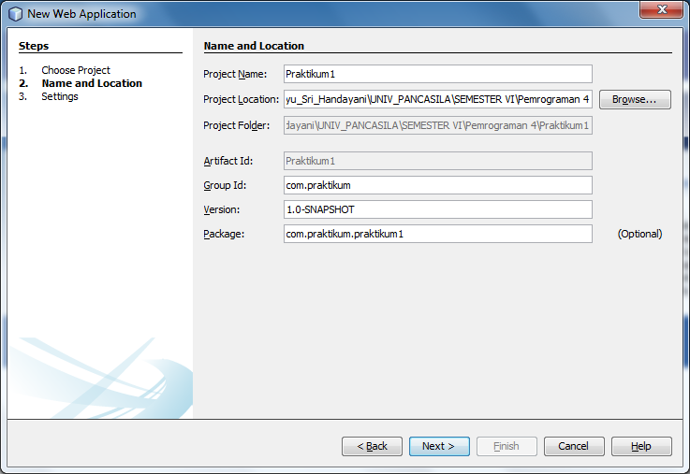

Langkah ketiga adalah pilih server yaitu **Apache** dan **Java EE Versionnya** yang **Java EE 6 Web** lalu klik finish

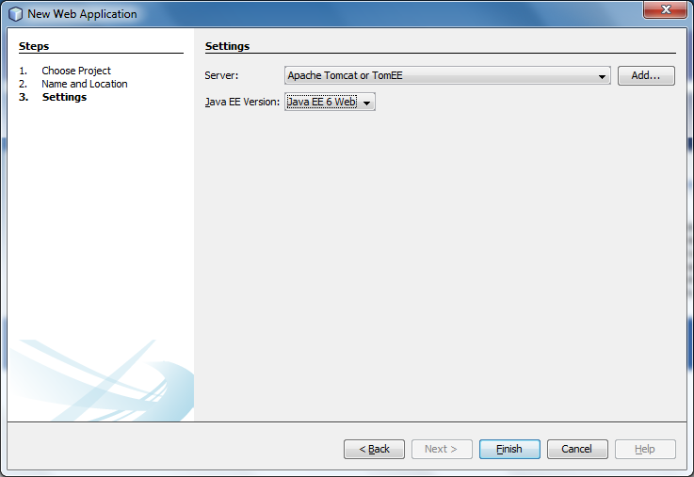

Hasil Output

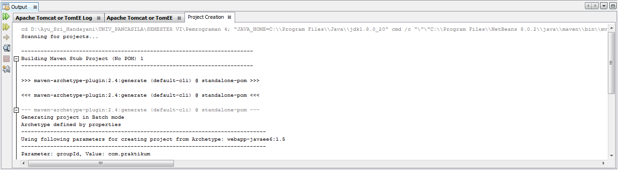

Setelah hasil output tersedia, lanjut dengan membuat HTML yaitu pilih **Web Pages 🡪 HTML** dan masukkan File Nama HTML saya namakan form-data

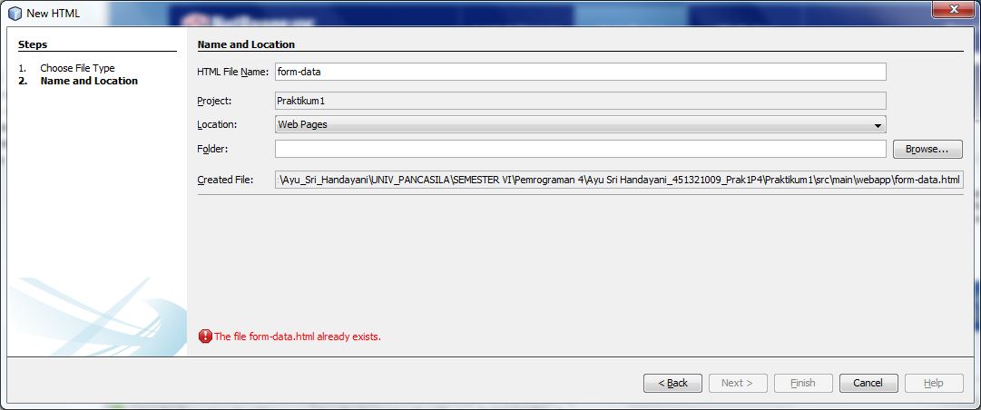

Source code HTML **(form-data.html)**

|  |
| --- |
| <html>  <head>  <title></title>  <meta charset="UTF-8">  <meta name="viewport" content="width=device-width, initial-scale=1.0">  </head>  <body>  <form action="ServletTest" method="POST">  Enter your name = <input type="text" name="username" value=""/>  <input type="submit" value="Send" name="send" />  </form>  </body>  </html> |

Source code **index.jsp**

|  |
| --- |
| <html>  <head>  <meta http-equiv="Content-Type" content="text/html; charset=UTF-8">  <title>JSP Page</title>  </head>  <body>  <h1>Hello World!</h1>  <br/>  <a href="./form-data.html">Pengisian Data</a>  </body>  </html> |

Langkah selanjutnya adalah membuat SERVLET, pertama-tama klik **Source Package 🡪 nama package (com.praktikum.praktikum1) klik kanan pilih New 🡪 Servlet**  masukkan Class Name lalu tekan **next 🡪 finish**

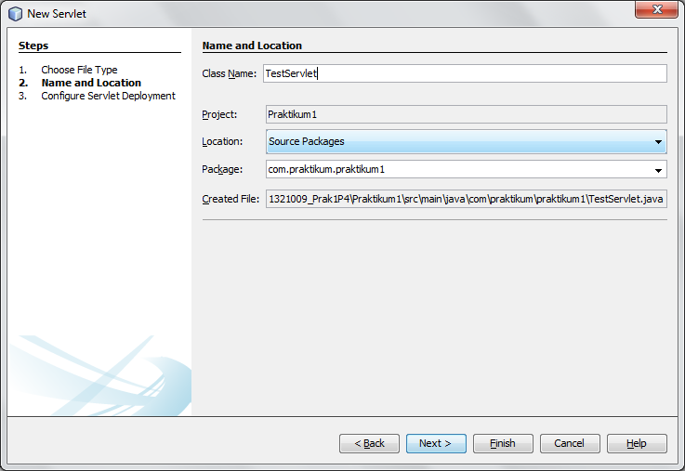

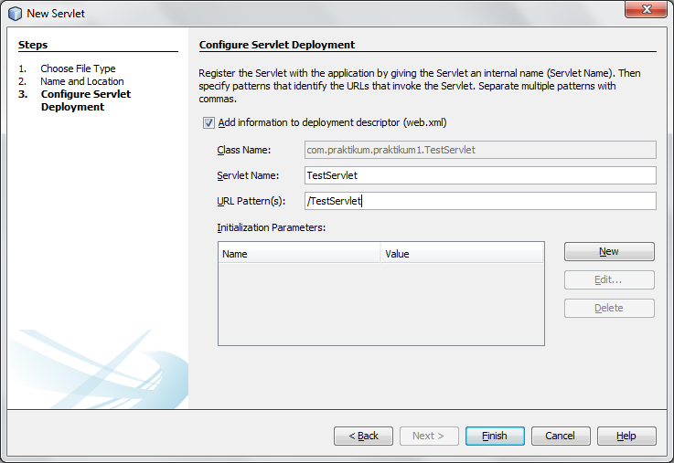

Source code Servlet

|  |
| --- |
| package com.praktikum.praktikum1;  import java.io.IOException;  import java.io.PrintWriter;  import javax.servlet.ServletException;  import javax.servlet.http.HttpServlet;  import javax.servlet.http.HttpServletRequest;  import javax.servlet.http.HttpServletResponse;  /**  *  * @author Asus  */  public class ServletTest extends HttpServlet {  protected void processRequest(HttpServletRequest request, HttpServletResponse response)  throws ServletException, IOException {  String userName = request.getParameter("username");  userName = userName.toUpperCase();  response.setContentType("text/html;charset=UTF-8");  PrintWriter out = response.getWriter();  try {  /* TODO output your page here. You may use following sample code. */  out.println("<!DOCTYPE html>");  out.println("<html>");  out.println("<head><title>Servlet</title></head>");  out.println("<body>");  out.println("<h1>");  out.println("Hello, " + userName + "!");  out.println("</h1>");  out.println("</body>");  out.println("</html>");  } finally {  out.close();  }  }  // <editor-fold defaultstate="collapsed" desc="HttpServlet methods. Click on the + sign on the left to edit the code.">  /**  * Handles the HTTP <code>GET</code> method.  *  * @param request servlet request  * @param response servlet response  * @throws ServletException if a servlet-specific error occurs  * @throws IOException if an I/O error occurs  */  @Override  protected void doGet(HttpServletRequest request, HttpServletResponse response)  throws ServletException, IOException {  processRequest(request, response);  }  @Override  protected void doPost(HttpServletRequest request, HttpServletResponse response)  throws ServletException, IOException {  processRequest(request, response);  }  /**  * Returns a short description of the servlet.  *  * @return a String containing servlet description  */  @Override  public String getServletInfo() {  return "Short description";  }// </editor-fold>  } |

Hasil

